Data Visualisation - Assignment 2 _HDip 2019

R00181392 Svetlana Ivanov

**Evaluation and implementation of visualisation technique using Shinydashboard and Power BI.**

**Dataset:**

I created my dataset from <https://www.gapminder.org/> site and additional files about countries division to different regions.

Dataset was used for the previous visualisation project and the head of the file looks like this:

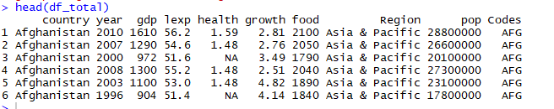

As files that I got were a very different one from another and contain a lot of missing data, I decided to limit my project to the most consistent years between 1995 and 2010. All other years were dropped from the dataset.

In this project I decided to replicate all visualisation from my first project in plotly, but this time to create 2 dashboards: one in the shiny dashboard and one in Power BI and to compare these 2 tools and their possibilities.

**General considerations about tools :**

First of all, I want to mention that Shiny dashboard is a free to use R package and Power BI is a Microsoft product that you have to pay for. When I choose a free version and tried to sign up, it requested a work email address. Indicating that I am a student didn’t help, as CIT doesn’t give permission for Power BI signing up. Because of this I had to create my files anonymously and not all options were opened for me. Subscription for the tool is € 99 per year and there isn’t an option for a monthly subscription.

Because of this, it will be impossible to give a complete estimation of this tool.

From another hand, Shiny dashboard is a tool, where everything has to be developed and described by the user and it requires a certain level of R programming skills, takes a huge amount of time for creation and personalisation of a dashboard. The total amount of time spent for my shiny dashboard visualisation was about 20 -25 hours considering that most graphs were already developed for the previous project and had to be only adapted for this one.

Time spent for the Power BI project also included some study, but it didn’t require a special level of programming languages, only a basic understanding of data reporting. Power BI tool can be used by any person, who has some knowledge about statistics and visualisation.



***Layouts:*** Both Shiny and Power BI have options to change page layout. In Shiny we are using for this goal option fluidPage() and fluidRow() functions. Power BI has a usual and a phone Layout.



*M****ultiple Pages:*** Power Bi has an option for adding new pages, in Shiny we can add Panels (Pages) with ConditionalPanel() function.

***Work with data tables:***

Using plotly in Shiny, we can have an interactive way to show a Data table. Sider panel also gives the possibility to add some widgets for the table analysis. Power BI has a very large spectre of tools and options to show and analyse a table, adding different colours, metrics and analytics. In Power BI it is possible to assign a gradient background or font color for every column, as it is shown in my screenshot for column lexp. It is easy to assign different filters to the hole page, every table or to certain columns.

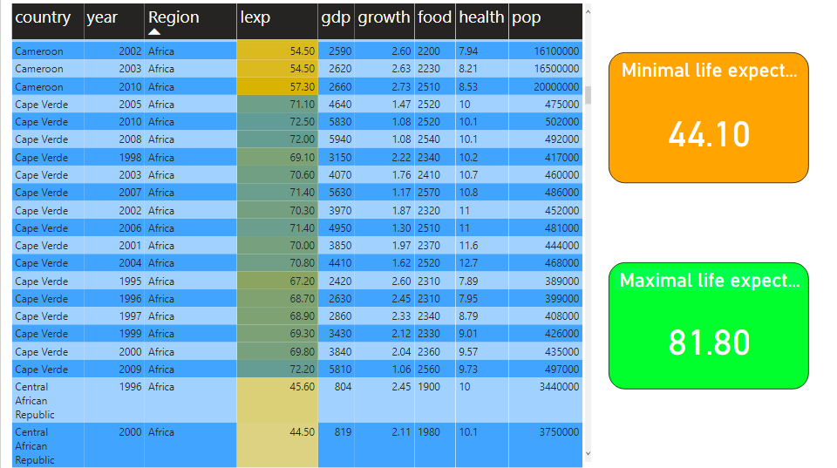

All these things can be done in Shiny dashboard too, but they require more time for development. A variety of tools on the page sidebar helps to achieve a very high level of interactive filtering.

Of course, a lot of features in Power BI can be added by inserting some code in R or Python, but I want to show here only that options and possibilities that can be created using only native Power BI tools.

In my opinion Power BI is a very good tool for reporting, manipulating and analysing Data by a specialist in marketing or even a manager, who needs to see different aspects of company’s activity and who doesn’t have a special level of knowledge in coding or visualisation.

Shiny dashboard, from another hand, has its pluses when we speak about a nice presentation of Data or about an interactive website. Shiny has the possibility to reload data periodically and keep data tables analysis and visualisation actual without uploading a new data every time as it is required in Power BI.

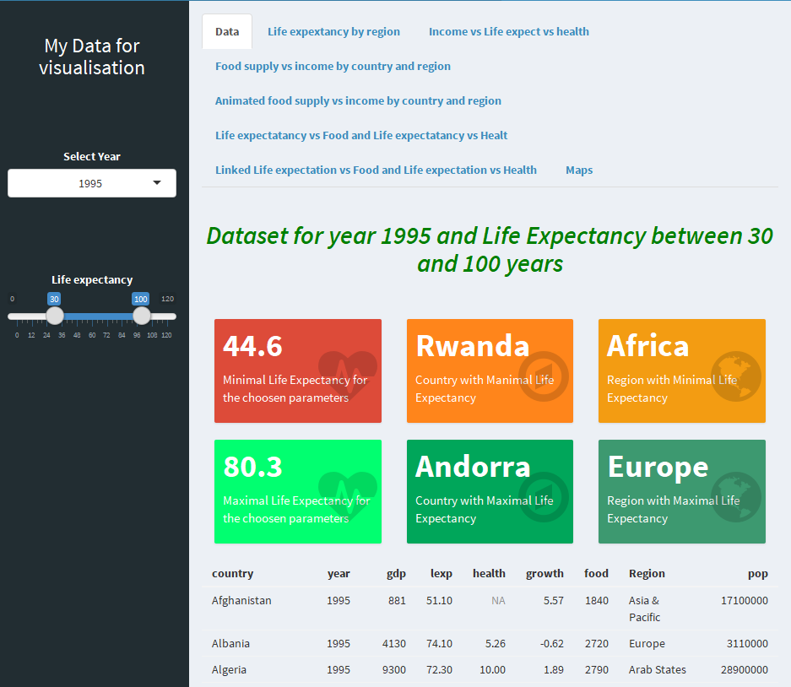

***Visualisation:***

**ValueBox vs Card:** Shiny has a function ValueBox() that can be considered analogue to Card option in Power BI and is used for visualising some statistics or totals. As we can see from examples below, the Shiny option has a lot more possibilities to make it mice and meaningful.

ValueBox: Power BI Card:

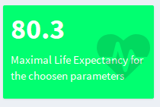 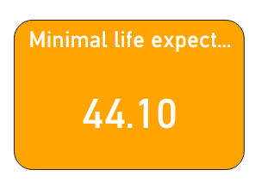

**Graphs:**

Power BI has a number of graphs ready to use as we can see here: 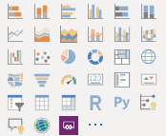

Most of them are standard graphs with a poor colour option.

**Boxplots:**

There isn’t an option for Boxplots in Power BI. Because of this my replacement for boxplot in Shiny

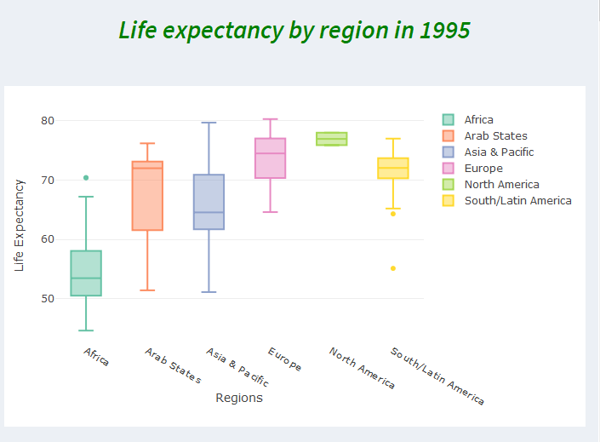

was replaced with a funnel graph in Power BI:

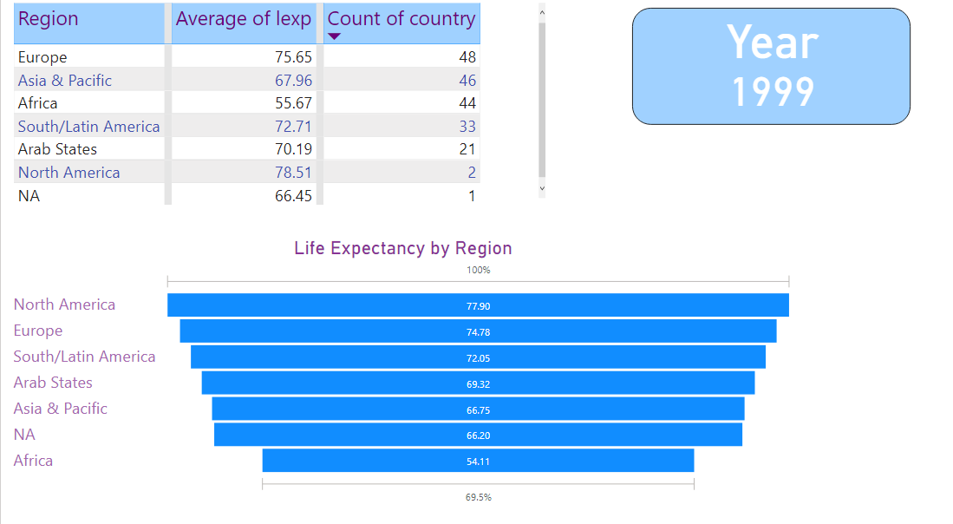

**Scatterplots:**

There are scatterplots in Power BI, but options in Shiny look more impressive in colour and general view:

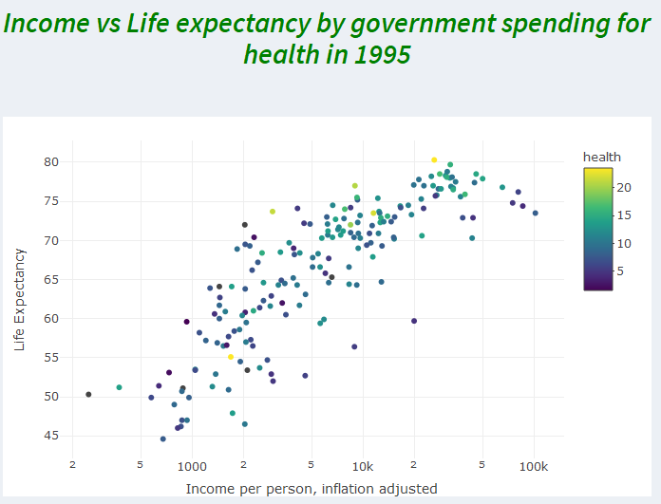

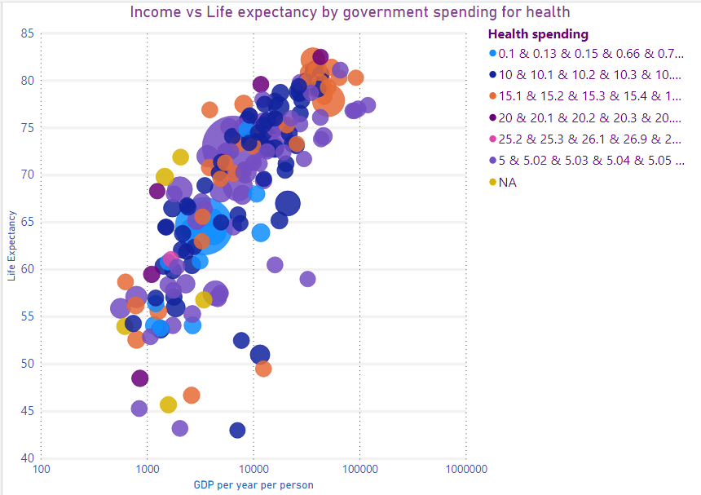

The problem is that there isn’t a dot transparency in Power BI and the binning option is very difficult to achieve

To create a binning in Power BI, it is necessary to use Group option, where you get a list of all values of a continuous variable and have to group them manually. It is not very convenient and takes a lot of time.

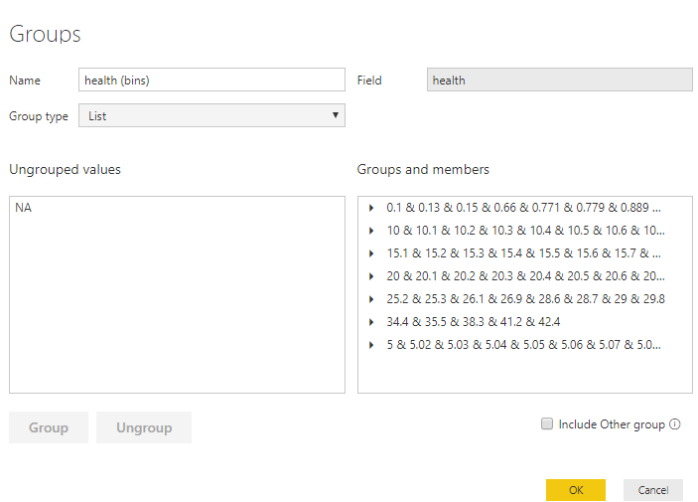

**Crosslinking:**

Both tools are very good in crosslinking as they have common filters for their pages:

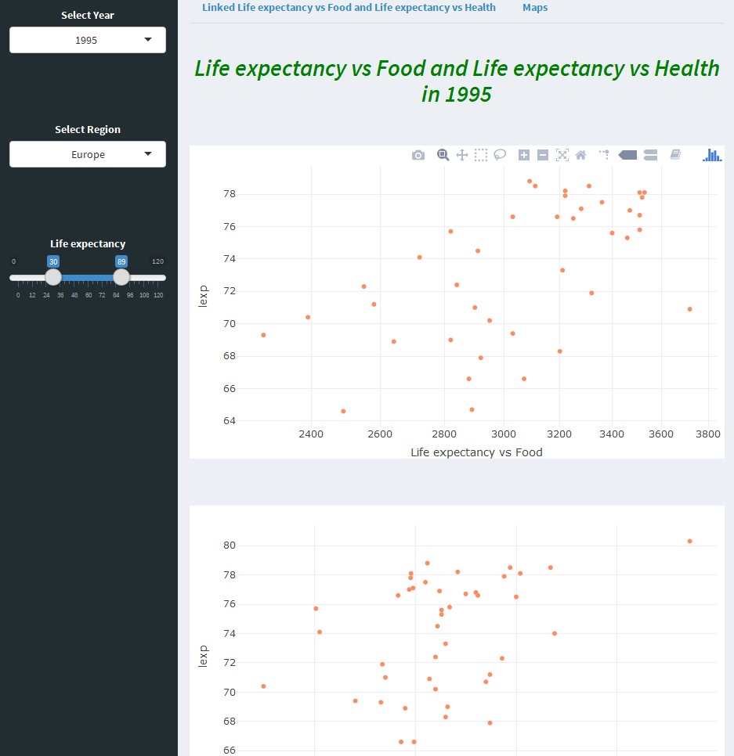

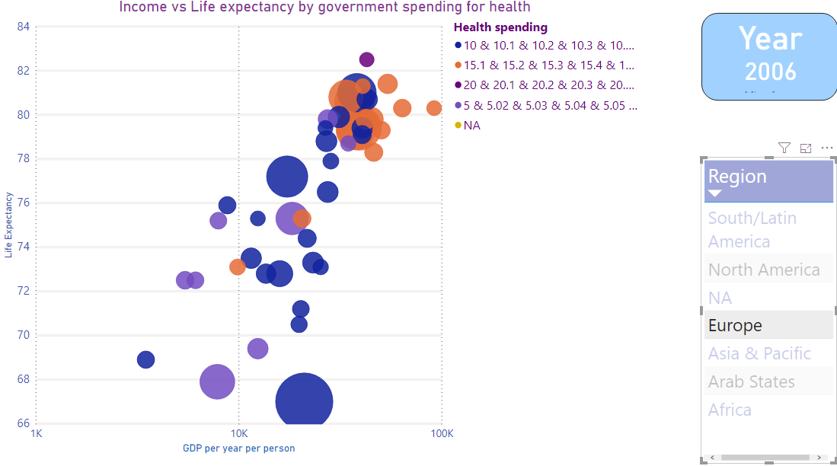

In Power BI crosslinks can be created by showing on the page a column or another graph with categorical data. The best way to show it is by using Treemap graphs as an example:

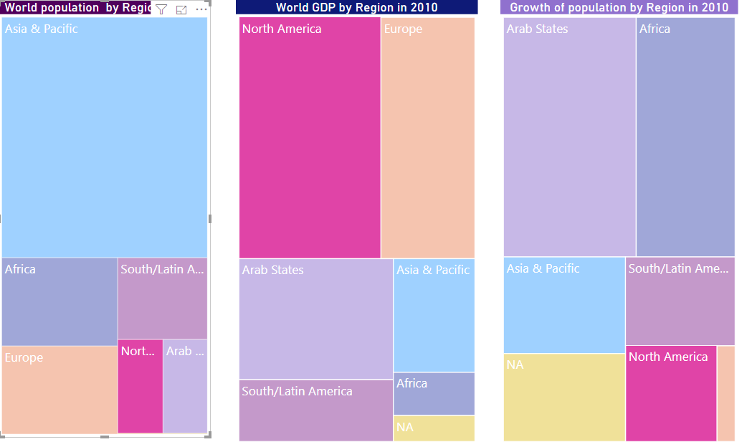

In Shiny this method is also working, but here additionally we can use selection by mouse.

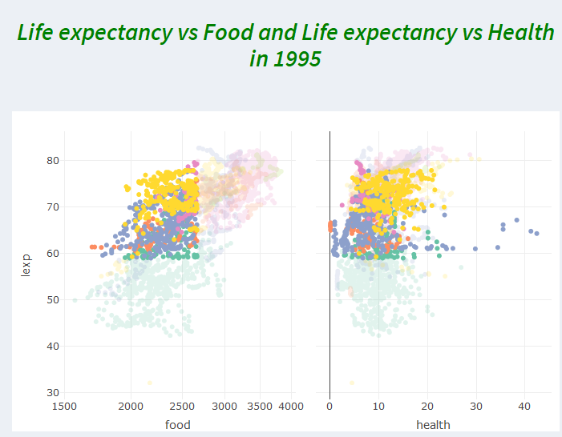

**Animation:**

Both tools have graph animation. The difference is that in Shinydashboard animation has more options for customisation.

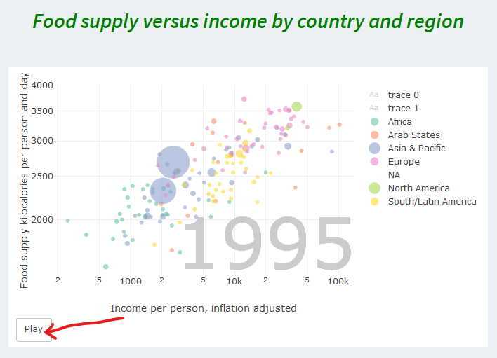

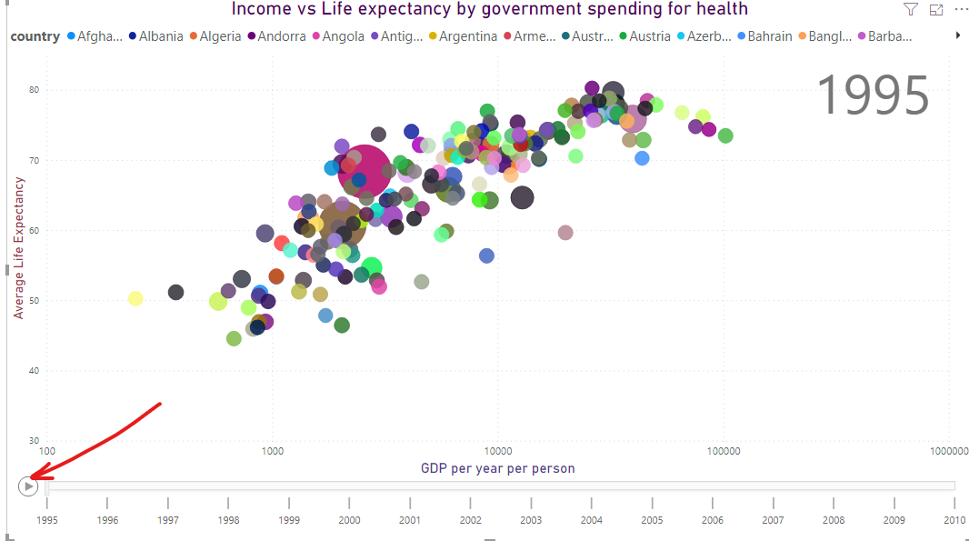

**Maps:**

Both Power Bi and Shinydashboard support use of maps. In Power BI was easy to create a standard map after binning manually government spending for health as below.

But maps in Shiny are a lot better and more readable than in Power BI. Also, I managed to place on one page a wide range of maps.

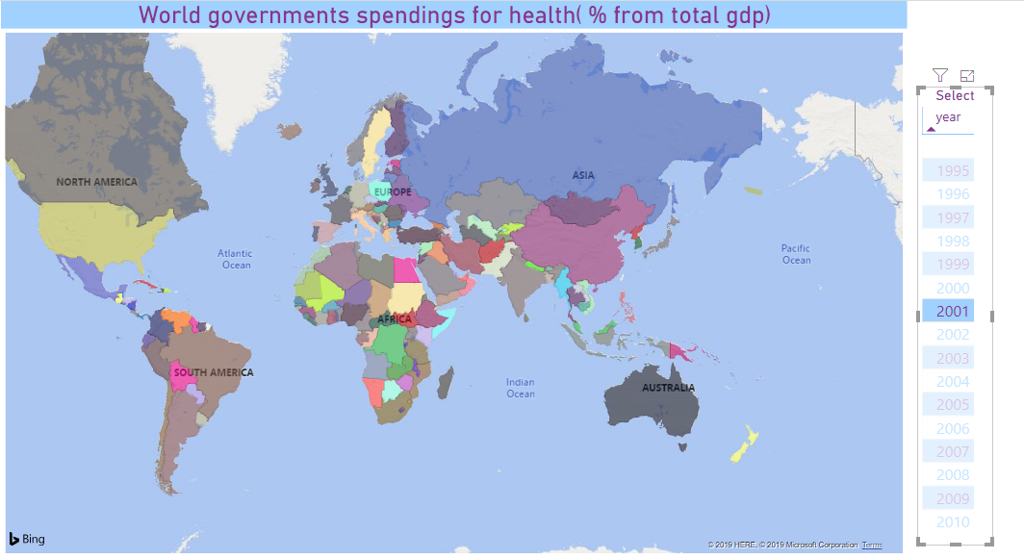

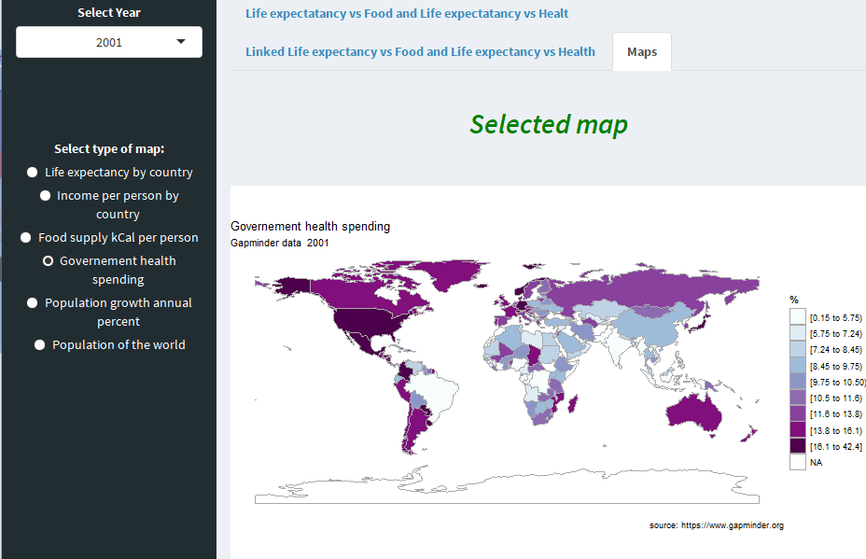

***General conclusions:***

**Power BI** is a **reporting** and analysing tool and it is very good for day by day activity and work. Can be easily used by specialists and managers that have some knowledge in Data management and need this tool in the process of taking decisions. It can be used by visualisation specialists but requires an additional input that it is not worth to waste on this tool and can give better results by using something else.

Visualization, on the other hand, is an active participant in wringing the truth out of data. No analytical work is complete without it. But it’s not just an add-on at the end or a pleasant veneer to a perfectly fine set of analytics. It’s vital to how analytics is understood and perceived. Unlike reporting, visualization has a unique ability to clarify murky ideas and make connections that otherwise would have been missed.

If a report analyst can produce a vast quantity of reports, user’s engagement in such dashboards is usually low. Visualisation is very important for data understanding, but it is hard to execute well. Visualization, however, requires expertise in fields that are notoriously hard to define and master such as psychology, visual perception, and communication. By its nature, visualization is relational and contextual and cannot be hardened into a rigid set of rules. There are too many variables at play when it comes to communicating with and influencing human beings. What works for one set of data doesn’t work for another. What works for one group of people doesn’t work for another. IT is a highly customized solution for highly complex and unique problems. And such goals are hard to achieve in a standard tool as Power BI or Excel.

Using a programming language or a more sophisticated tool can give a lot of better results.

Many companies are satisfied by using such tools as Power Bi, but our job as Data Scientists is to prove that good visualisation matters by creating great projects. We have to help real people find meaning in their data and use it well.

Of course, creating a nice, meaningful and clear Shiny dashboard takes time and skills, but the result is worth it.